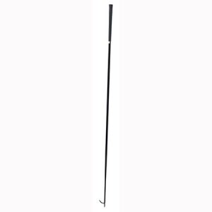
Heifer and Steer Supplies
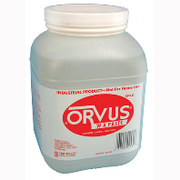
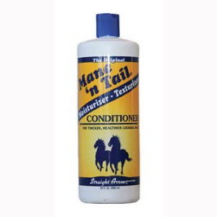
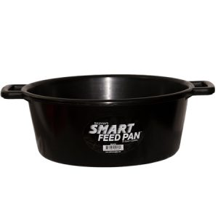
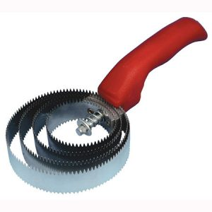
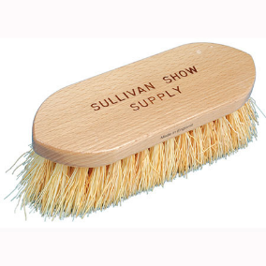
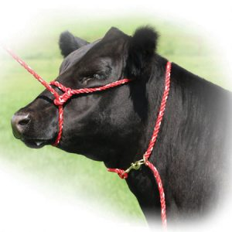

Martin’s Farm and Ranch Innovative Feeds
215 E Monte Cristo Rd, Edinburg, TX 78541 311 N. Shary Blvd.
956.383.4949 Alton, TX
Linder Feed, Purina, Moorman 956.358.4043
Linder, Moorman, Essential, Ful-O-P
Tandy’s Farm and Ranch
6015 N Expressway 281, Edinburg, TX 78542
(956) 381-0263
Ful-O-Pep, Essential Feeds

