Hog Supplies and Feed

Martin’s Farm and Ranch
215 E Monte Cristo Rd, Edinburg, TX 78541
956.383.4949
Linder Feed, Purina, Moorman

Tandy’s Farm and Ranch
6015 N Expressway 281, Edinburg, TX 78542
(956) 381-0263
Ful-O-Pep, Essential Feeds

Innovative Feeds
311 N. Shary Blvd.
Alton, TX
956.358.4043
Linder, Moorman, Essential, Ful-O-Pep
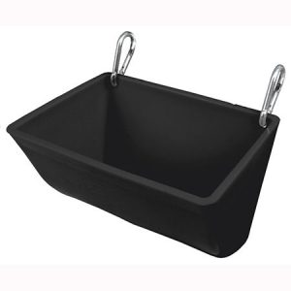
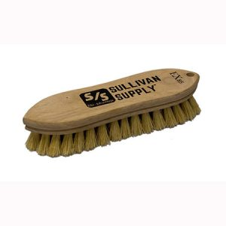
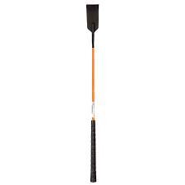

Other Suppies:
2 ½ gallon plastic water bucket, Soap, Feed Supplements, show clip or vest, and wet wipes

